**COMSATS University Islamabad (Lahore** **Campus)**

**Quiz 1** **– Spring 2025**

|  |  |  |  |  |  |
| --- | --- | --- | --- | --- | --- |
| Course Title: | Object Oriented Programming | Course Code: | CSC241 | Credit Hours: | 4 |
| Course Instructor/s: | M. Mohsin Mehdi | Program Name: | BCS/BSE Repeaters | | |
| **Time Allowed:** |  | **Maximum Marks:** | | **16** | |
| **Important Instructions / Guidelines:** | | | | | |

***Question No 1.* Marks: 2X8=16**

***CLO: <2>; Bloom Taxonomy Level: <****Applying****>***

***Apply the concepts of event driven programming.***

1. **Below is an incomplete Java program. Complete the Person class and answer the following question.**

class Person {

// Define instance variables: name (String) and age (int)

Private String name;  
private int age;

// Constructor to initialize name and age

Person (String n, int a) {  
 name = n;  
 age = a;  
}

// Method to display details

void display () {  
 System.*out*.println("Name: " + name + ", age: " + age);  
}

}

public class Main {

public static void main(String[] args) {

Person p1 = new Person("Alice", 25);

p1.display();

}

}

What will be the output of the completed program if display() prints the name and age?

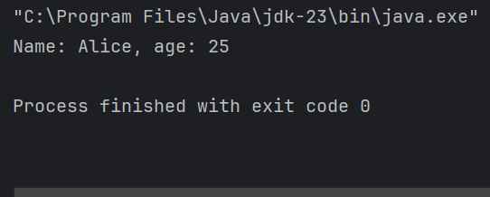

1. Analyze the following Java code snippet and predict the output:

public class ArrayExample {

public static void main(String[] args) {

int[] arr1 = {1, 2, 3};

int[] arr2 = arr1;

arr2[0] = 10;

System.out.println(arr1[0]);

}

}

What will be the output?

10

1. Analyse the following code snippet:

public class StringExample {

public static void main(String[] args) {

String str = "JavaProgramming";

System.out.println(str.substring(4, 10));

}

}

What will be the output?

Progra

1. Which of the following statements about Java OOP is **false**?

* a) A class can have multiple constructors with different parameters.
* b) An object is an instance of a class.
* c) A constructor must always have a return type.
* d) Arrays can store objects in Java.

Answer:

(C)

1. Consider the following Java code:

class Example {

int x;

Example() {

x = 10;

System.out.println("Constructor called");

}

}

public class Main {

public static void main(String[] args) {

Example obj = new Example();

System.out.println(obj.x);

}

}

What will be the output?

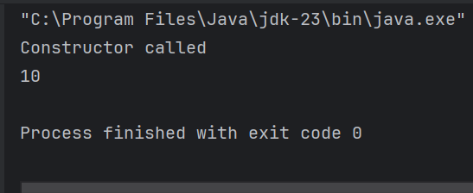

1. What will be the output of the following Java program?

public class ArrayTest {

public static void main(String[] args) {

int[] numbers = new int[5];

numbers[2] = 50;

System.out.println(numbers[2]);

}

}

Output:

50

1. What will be the output of the following Java code?

public class StringComparison {

public static void main(String[] args) {

String s1 = new String("Hello");

String s2 = "Hello";

System.out.println(s1 == s2);

}

}

Output:

False

1. Which of the following statements about instance and local variables in Java is **true**?

* a) Instance variables are declared inside methods.
* b) Local variables are automatically initialized.
* c) Instance variables belong to an object and are accessible in all methods of the class.
* d) Local variables can be accessed by all methods in the class.

Answer:

(c)